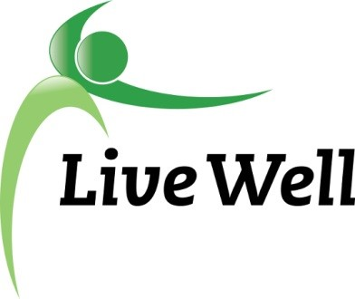

LiveWell Douglas County Executive Director
Position Description

LiveWell Douglas County seeks an Executive Director to provide cohesive leadership and backbone support for this community wellness coalition. The newly created position will be responsible for building and maintaining community partnerships while supporting the core functions of the coalition. The successful candidate will be an entrepreneurial, detail-oriented individual with a shared passion for our mission: Leading a movement to build communities that support the health and well-being of all. This position will be full-time, permanent, subject to continued funding, and will be housed at [XXX organization]. This position will report to the LiveWell Douglas County Leadership Team. This position necessitates the ability to work a flexible schedule, including some evening and weekends.

Responsibilities: Working in concert with the LiveWell Executive Committee and Leadership Team, the Executive Director will be responsible for the following:

Budgeting and Financial Management
- Grant writing and fundraising: Pursue external funding sources through grant-writing and partnership development to support activities of the coalition and individual work groups. Coordinate public fundraising campaigns as needed.
- Budgeting: Develop an annual budget for coalition expenses. Prepare budget reports for Executive Committee and Leadership Team meetings. Coordinate with fiscal agents to ensure approved payments are made to vendors.
- Grant and financial reporting: Complete all reporting requirements for grants and gifts. Prepare annual report for the Executive Committee and Leadership Team.
Public Communications
- Media representative: Serve as the public face of LiveWell Douglas County. Interact with local media and community partners. Coordinate with Lawrence-Douglas County Health Department on distributed media, including providing content for newsletter and social media platforms.
- Community partnerships: Develop and maintain relationships with community partners, including businesses, non-profit organizations, local governments, and community members. Stay apprised of related projects in the community to identify potential collaborations and opportunities for cross-promotion.
- Annual events: Coordinate annual public events of the coalition, including the annual awards celebration breakfast, anniversary events, and other public forums.
Coalition Management
- Training and orientation: Provide training and orientation on communication and documentation platforms for new members of the leadership team. CHIP alignment: Provide assistance to work groups in aligning work with the Community Health Improvement Plan and documentation of those activities.
- Documentation: Document accomplishments of the work groups, coalition, and community partnerships, including documentation of coalition activities related to the Community Health Improvement Plan in the Community Check Box.
- Membership: Maintain contact lists and communication platforms for work groups and the coalition. Maintain communication and engagement with past, current, and future members.
- Staff and Volunteers: Oversee interns, contractors or other willing volunteers for coalition management.
- Advocacy: Coordinate with the Leadership Team to develop an advocacy agenda for individual work groups and the coalition as a whole.

Required Qualifications:
- Bachelor’s degree
- Academic coursework and/ or professional development or professional employment related to the position responsibilities
- 3 years of coalition and/ or nonprofit management experience
- Strong knowledge of and ties to the community
- Experience writing, applying for, administering, and managing grants
- Experience developing and administering budgets
- Ability to thrive in a fluid, unstructured, entrepreneurial environment
- Ability to work autonomously as well as take direction as needed
- Ability to build relationships with new and existing stakeholders
- Strong computer skills, including the use of communication and financial tools, and various online platforms
- Strong facilitation skills, including ability to work with diverse groups and individuals to a establish goals and develop consensus-based solutions.
- Excellent communication skills, including writing and personal communications.
- Experience working with diverse individuals and groups

Preferred Qualifications:

- Post-secondary degree in public administration, public health, community health, non-profit management, or related field

